Project Proposal — Phase 2
Age Group Estimation from Facial Images using CNNs
Machine Learning Course — Applied CNN-based Image Classification

1. Project Title
Age Group Estimation from Facial Images using Convolutional Neural Networks.

2. Background and Motivation
Estimating a person’s age from a facial image is a well-studied computer-vision problem with practical uses in access control, audience analytics, content personalization, and demographic research. The human face carries strong visual cues to age — skin texture, facial proportions, and the presence of features such as wrinkles — but these cues vary widely across individuals, lighting, pose, and image quality, which makes the task non-trivial.
Convolutional Neural Networks (CNNs) are well suited to this problem because they learn hierarchical visual features directly from pixels, removing the need for hand-crafted descriptors. This project applies the supervised-learning and CNN concepts from the course to build, train, and evaluate a model that predicts a coarse age group rather than an exact age, which is both more robust and sufficient for many real applications.

3. Problem Statement
Given a single RGB facial image, the goal is to classify the person into one of six predefined age groups. The continuous age label provided by the dataset is discretized into ordered age bands, turning age estimation into a multi-class image-classification task. The main challenges are the natural class imbalance of the dataset (young adults are over-represented) and the visual similarity between neighbouring age bands.

4. Selected Dataset and Dataset Link
UTKFace (the “utkface-new” release on Kaggle) is used for this project.
Dataset link: https://www.kaggle.com/datasets/jangedoo/utkface-new

5. Dataset Description
- Number of images: 23,708 face images (aligned and cropped version).
- Number of classes: 6 age groups (derived by binning the continuous age label).
- Image type: RGB facial images in JPEG format, aligned and cropped to roughly 200×200 pixels; resized to 128×128 for the model.
- Labels: encoded in each filename as [age]_[gender]_[race]_[datetime].jpg; only the age field is used.
- Class distribution: imbalanced — the 20–34 band dominates (9,634 images) while 13–19 is smallest (1,180). This is handled with balanced class weights during training.
The continuous age is mapped to the following six ordered groups (image counts from the dataset):
Class | Age range | Label | Images
0 | 0–12 | Child | 3,413
1 | 13–19 | Teenager | 1,180
2 | 20–34 | Young Adult | 9,634
3 | 35–49 | Adult | 4,492
4 | 50–64 | Middle-Aged | 3,031
5 | 65+ | Senior | 1,958

6. Research Questions
- RQ1: How accurately can a custom CNN classify faces into six age groups from the UTKFace dataset?
- RQ2: Does transfer learning with a pre-trained MobileNetV2 outperform a CNN trained from scratch on this task?
- RQ3: Which age groups are most often confused with one another, and do errors concentrate between adjacent age bands?
- RQ4: Which facial regions does the model rely on when predicting age, as revealed by Grad-CAM?

7. Expected Results
A working six-class age-group classifier is expected, with the transfer-learning model (MobileNetV2) likely outperforming the custom CNN due to its pre-trained features. Most misclassifications are expected to fall between neighbouring age bands rather than distant ones. Grad-CAM is expected to show the model focusing on informative facial regions such as the eyes, cheeks, and forehead.
Because the dataset is imbalanced (see the class distribution below), per-class precision and recall are expected to be lower for the under-represented bands (13–19 and 65+); balanced class weights are used to mitigate this.
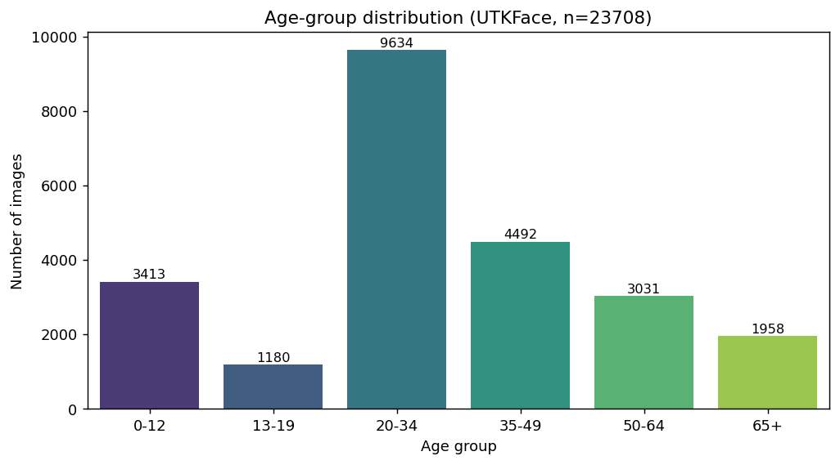
Figure 1. Age-group class distribution of the UTKFace dataset (n = 23,708).

8. Proposed Methodology
- Load images and parse the age label from each filename, skipping malformed files.
- Bin continuous ages into the six age groups.
- Perform exploratory data analysis (class distribution and sample images).
- Split the data into training, validation, and test sets (70 / 15 / 15) using stratified sampling.
- Preprocess: resize to 128×128, normalize pixels to [0, 1], and apply data augmentation (rotation, shift, zoom, horizontal flip) to the training set only.
- Apply balanced class weights to counter class imbalance.
- Train a custom CNN, then train a MobileNetV2 transfer-learning model in two stages (feature extraction followed by fine-tuning).
- Evaluate both models and compare results.

9. CNN Model Design
The custom CNN consists of four convolutional blocks with increasing filter counts, followed by a classification head:
- Four blocks of Conv2D (32 → 64 → 128 → 256 filters, 3×3 kernels, ReLU) → BatchNormalization → MaxPooling2D.
- GlobalAveragePooling2D to flatten feature maps.
- Dropout (0.4) → Dense (256, ReLU) → Dropout (0.3).
- Output Dense layer with 6 units and softmax activation.
The model is compiled with the Adam optimizer and categorical cross-entropy loss. EarlyStopping and ReduceLROnPlateau callbacks are used to control training.

10. Transfer Learning Models
MobileNetV2 pre-trained on ImageNet is used as the transfer-learning model. The convolutional base is first frozen and only a new classification head (GlobalAveragePooling2D → Dropout → Dense(128, ReLU) → Dropout → Dense(6, softmax)) is trained. The top layers of the base are then unfrozen and fine-tuned with a low learning rate so the pre-trained features adapt to facial images.

11. Evaluation Metrics
- Accuracy on the held-out test set.
- Precision, recall, and F1-score per class (classification report).
- Confusion matrix to identify which age groups are confused.
- Training and validation accuracy/loss curves to assess fit and overfitting.
- Side-by-side comparison of the custom CNN and MobileNetV2.

12. Expected Figures and Tables
- Bar chart of the age-group class distribution.
- Grid of sample images, one per age group.
- Accuracy and loss curves for both models.
- Confusion matrix for each model.
- Classification report (precision/recall/F1) for each model.
- Model comparison table and bar chart of test accuracy.
- Grad-CAM visualizations highlighting influential facial regions.
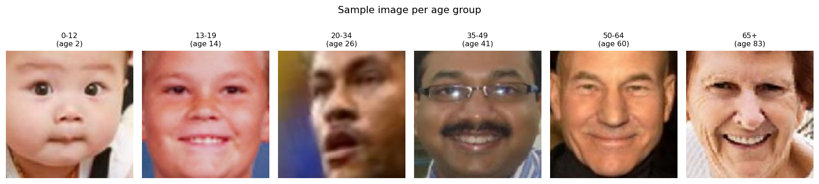
Figure 2. One sample image per age group from the UTKFace dataset.

